

|  |  |  |
| --- | --- | --- |
| 10/07/2023 | Credit Card |  |
|  |  |
|  | Default Project |  |
|  | High Level Document (HLD) |  |

Yash Kumar Singh

Vaibhav Srivastava

CREDIT CARD DEFAULT PROJECT

Contents

|  |  |  |  |
| --- | --- | --- | --- |
| Abstract ....................................................................................................................................... | | | 2 |
| 1 | Introduction.......................................................................................................................... | | 3 |
|  | 1.1 | Why this High-Level Design Document?........................................................................... | 3 |
|  | 1.2 | Scope ............................................................................................................................ | 3 |
|  | 1.3 | Definitions ..................................................................................................................... | 3 |
| 2 | General Description............................................................................................................... | | 4 |
|  | 2.1 | Product Perspective ....................................................................................................... | 4 |
|  | 2.2 | Problem Statement ........................................................................................................ | 4 |
|  | 2.3 | Proposed Solution .......................................................................................................... | 4 |
|  | 2.4 | Technical Requirements ................................................................................................. | 4 |
|  | 2.5 | Dataset.......................................................................................................................... | 4 |
|  | 2.6 | Tools and technologies used ........................................................................................... | 5 |
| 3 | Design Details ....................................................................................................................... | | 6 |
|  | 3.1 Process Flow ....................................................................................................................... | | 6 |
|  | 3.2 Deployment Process ............................................................................................................ | | 6 |
|  | 3.3 Event Log ............................................................................................................................ | | 6 |
|  | 3.4 Performance ....................................................................................................................... | | 6 |
|  | 3.5 | Reusability .......................................................................................................................... | 7 |
|  | 3.6 | Application Compatibility ..................................................................................................... | 7 |
|  | 3.7 Deployment ........................................................................................................................ | | 7 |
|  | 3.8 User Interface ..................................................................................................................... | | 7 |
| 4 | XGBoost Model Classification report ...................................................................................... | | 8 |
| 5 | Conclusion ............................................................................................................................ | | 9 |



1 | P a g e

CREDIT CARD DEFAULT PROJECT

Abstract

Financial threats are displaying a trend about the credit risk of commercial banks as the incredible improvement in the financial industry has arisen. In this way, one of the biggest threats faced by commercial banks is the risk prediction of credit clients. The goal is to predict the probability of credit default based on credit card owner's characteristics and payment history.

Use of various classification models like Decision Tree, Random Forest, XGBoost, MLPClassifier was done. XGBoost was selected as best model from above. The XGBoost model provided 82.63% accuracy in training. Testing accuracy for model was 82.3%. 80% data was used for training and 20% data was used for testing.

After Providing various details the model will predict whether customer will default next month or not. Model will also predict probability of default.



2 | P a g e

CREDIT CARD DEFAULT PROJECT

1 Introduction

1.1 Why this High-Level Design Document?

The Purpose of this High-Level Design Document is to add necessary detail to the current project description to represent a suitable model for coding. This document is also intended to help and detect contradictions prior to coding and can be used as a reference manual for how modules interact at higher level.

The HLD will:

1. Present all of design aspects and define them in detail.
2. Describe the user interface being implemented.
3. Describe software interfaces.
4. Include Design features and architecture of the project.

1.2 Scope

The HLD document presents the entire structure of the project in parts, such as the data ingestion, data pre-processing, solution development, and the deployment part along with their respective architectures. This uses non-technical to mild technical terms which should be understandable to the administrators of the system.

1.3 Definitions

|  |  |
| --- | --- |
| **Term** | **Description** |
| IDE | Integrated Development Environment |
| EDA | Exploratory Data Analysis |
| XGBoost | Extreme Gradient Boost Algorithm |
| ML | Machine Learning |
| MLP | Multi-Layer Perceptron Classifier |
| Classifier |  |
| KNN | K-Nearest Neighbours |
| VS Code | Visual Studio Code |



3 | P a g e

CREDIT CARD DEFAULT PROJECT

2 General Description

2.1 Product Perspective

This Credit Card Default Prediction is Machine Learning model based on XGBoost algorithm. Which helps us to predict whether customer will default next month payment or not. The app will also predict the probability of default.

2.2 Problem Statement

Financial threats are displaying a trend in the credit risk of commercial banks as the incredible improvement in the financial industry has arisen. In this way, one of the biggest threats faced by commercial banks is the risk prediction of credit clients. The goal is to predict the probability of credit default based on the credit card owner's characteristics and payment history.

2.3 Proposed Solution

The Solution here is a web application which takes the details of customer and those details will be taken by ML model in backend, which will predict whether customer will default or not. This app will also predict probability of default on front end page of user.

2.4 Technical Requirements

I used python version 3.10.7 with some important libraries to develop a machine learning model, which accurately predicts Yes/No and probability of credit card default.

Then, the model is used as a back-end software for a front-end web application which can be used by the users.

Front end is designed using Dash Library for this web app.

2.5 Dataset

For training and testing the model, I used the public data set available in Kaggle, “Default of Credit Card Clients Dataset” by UCI.

URL - [Credit Card Transactions | Kaggle](https://www.kaggle.com/datasets/ealtman2019/credit-card-transactions)

|  |  |  |  |  |
| --- | --- | --- | --- | --- |
|  | **Variable Name** | **Measurement** | **Description** |  |
|  |  | **Unit** |  |  |
|  | LIMIT_BAL | NT Dollar | Amount of given credit |  |
|  | SEX | Integer | Gender (1=male, 2=female) |  |
|  | EDUCATION | Integer | 1=graduate school, 2=university, 3=high |  |
|  |  |  | school, 4=others, 5=unknown, 6=unknown |  |
|  |  |  |  |  |
|  | MARRIAGE | Integer | Marital status (1=married, 2=single, |  |
|  |  |  | 3=others) |  |
|  | AGE | Years | Age of the person in years |  |
|  |  |  |  |  |
|  |  |  | 4 | P a g e | |

CREDIT CARD DEFAULT PROJECT

|  |  |  |
| --- | --- | --- |
| PAY_0-6 | Integer | Repayment status for various months |
| BILL_AMT1-6 | NT Dollar | Amount of billed statements for various |
|  |  | months |
| PAY_AMT1-6 | NT Dollar | Amount of Previous payments done |
| default.payment.next.month | Binary | Will Customer default? Yes/No |

2.6 Tools and technologies used

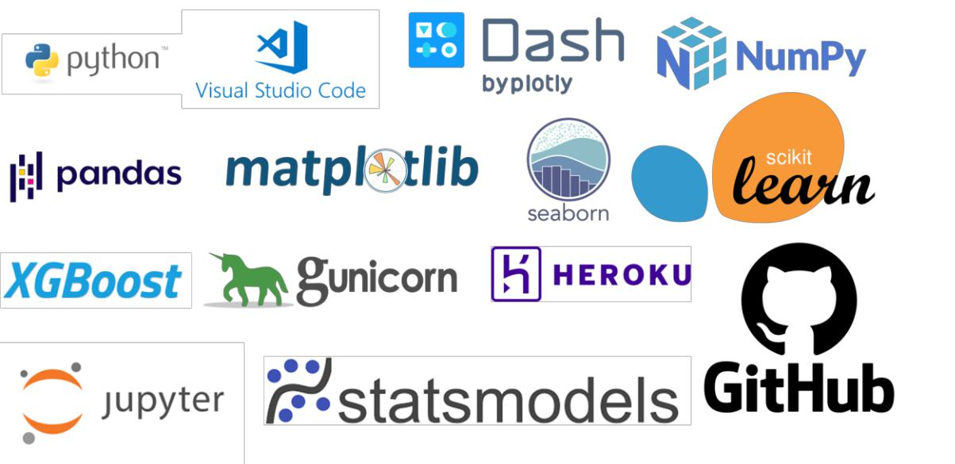

* Visual Studio Code (VS Code) was used as IDE (Integrated Development Environment). Everything including Jupyter notebooks, python apps, Git add, commit was done using VS studio Code.
* Jupyter Notebooks in VS Code were used for Exploratory Data analysis. Various Models like Decision Tree Classifier, Random Forest, XGBoost, KNN Classifier, MLP Classifier were tested in Jupyter Notebooks inside VS Code.
* VS Code was used to build .py files in which logging was also done. Other libraries used were Numpy, pandas, Matplotlib, Seaborn for further exploration.
* Dash Library was used to build the front end of the web application and interaction with backend was also done using dash call-back decorator.
* Statsmodels library is used for checking relationship with target variable.
* GitHub is used as Version Management System.
* Deployed the webapp using gunicorn and Heroku.



5 | P a g e

CREDIT CARD DEFAULT PROJECT

3 Design Details

3.1 Process Flow

|  |  |  |  |
| --- | --- | --- | --- |
| Data |  |  |  |
|  | Data |  |
| Collection |  | Ingestion |  |
|  |  |  |  |



|  |  |  |  |
| --- | --- | --- | --- |
| Model |  |  |  |
|  | Select best |  |
| Deploy |  | Model |  |
|  |  |  |  |



|  |  |  |
| --- | --- | --- |
| Application |  | Get Input |
| Start |  | from User |
|  |  |  |



3.2 Deployment Process

|  |  |  |  |
| --- | --- | --- | --- |
| Create |  |  |  |
|  | Create |  |
| Repository |  |  |
|  | Procfile |  |
| on Github |  |  |
|  |  |  |
|  |  |  |  |



Data Pre-

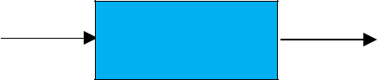

processing

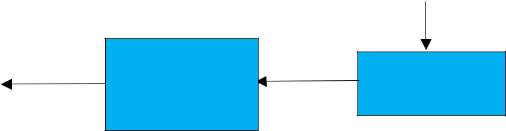

Evaluate

Model

Performance

Predict Will

default

Yes/No

Create New



Heroku App



Web App

ready

Exploratory

data analysis

Check Various

models

Predict



Probability

of Default



Link the

GitHub Repo

Deploy to

Heroku

3.3 Event Log

In this project, I used the “logging” library in both the development and deployment stages, which keeps logging the events at every step into the “.log” files. One of the advantages of event logging is, it makes debugging much easier, we can directly go to that specific line of code, which has errors.

3.4 Performance

The ML-based Probability of Default Predictor application is used for predicting the Probability Of Default based on various attributes of the customer. So, it should be as accurate as possible, so that it will not mislead the bank authorities. Model retraining is very important to keep it relevant in order to keep the model dynamic to changing times and customer behaviour.



6 | P a g e

CREDIT CARD DEFAULT PROJECT

3.5 Reusability

The code written and the components used can be reused without any problem. Model Pickle files are also created for every model tested.

3.6 Application Compatibility

The different components or modules of this project use python version 3.10.7 as their interface between them. Each component has its own task to perform and it is the job of the python version to ensure proper transfer of the information.

3.7 User Interface

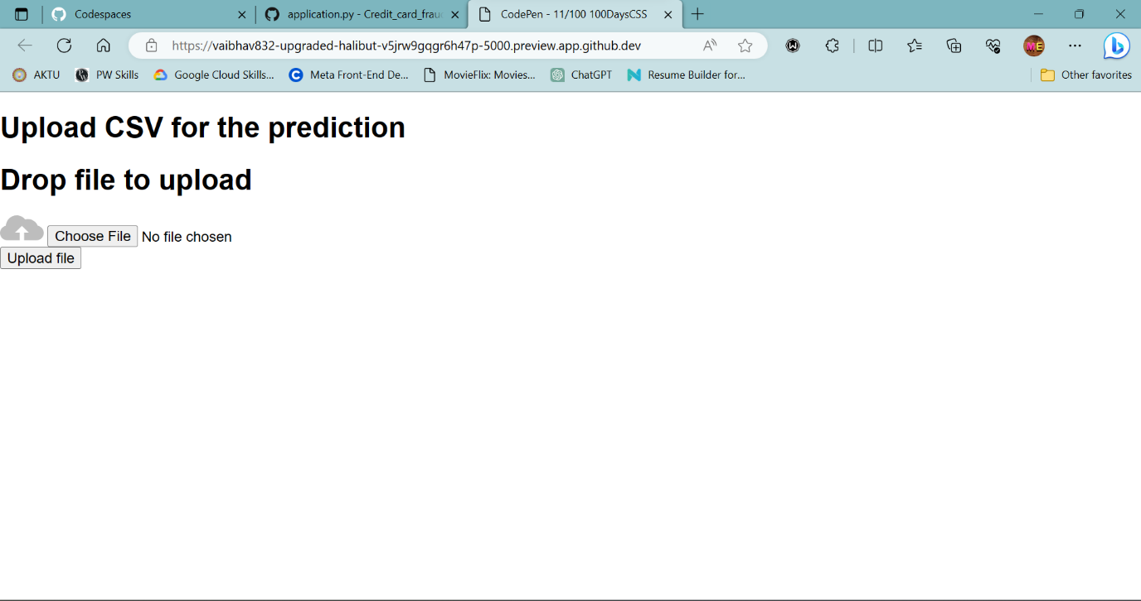



CREDIT CARD DEFAULT PROJECT

4 XGBoost Model Classification report

The XGBoost model used has 82.63% accuracy in testing and 82.3% accuracy in testing. Testing data is 20% of overall data.

Below is Classification report for selected XGBoost model .

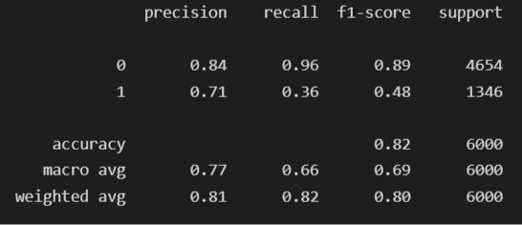

Below is feature importance for XGBoost model

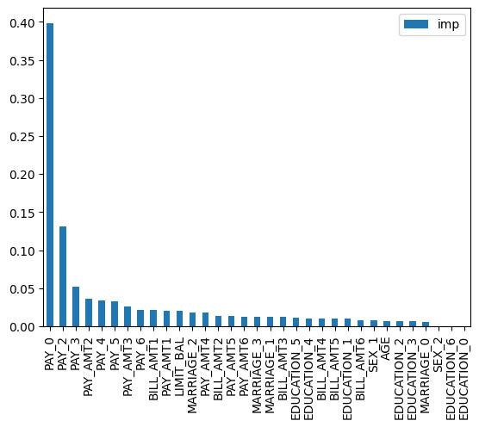

8 | P a g e

CREDIT CARD DEFAULT PROJECT

5 Conclusion

Credit Card Default Predictor is used to predict that customer will default or not and also the probability of default given various attributes of the customer using with the help of ML and Data Science techniques in order to reduce bad debts of the bank.



9 | P a g e